**Project Design Phase**

**Problem – Solution Fit Template**

|  |  |
| --- | --- |
| Date | 27 June 2025 |
| Team ID | LTVIP2025TMID43500 |
| Project Name | LearnHub:Your Center For Skill Enhancement |
| Maximum Marks | Marks |

**Problem–Solution Fit :**

The Problem–Solution Fit in LearnHub ensures that we are solving a real and pressing problem faced by our target audience—students and early professionals seeking practical, industry-relevant skills but lacking access to flexible, high-quality learning environments. Our platform addresses this gap by offering curated, interactive, and personalized skill-enhancement experiences aligned with market demands**.**

**Purpose:**

* Solve Real Learning Gaps: LearnHub is designed to solve the problem of traditional education not equipping learners with practical skills needed in today’s job market.
* Accelerate Growth and Adoption: By aligning with learner behavior—such as online content consumption, mobile learning, and project-based practice—LearnHub increases user engagement and adoption.
* Targeted Messaging and Positioning: Helps us communicate clearly to our users by tapping into their frustrations like outdated syllabi, lack of mentorship, and poor career guidance.
* Build Trust and Retention: LearnHub builds trust by consistently solving small but frequent pain points—like resume gaps, interview anxiety, or confusion about career paths—through workshops, mentorship, and guided learning paths.
* Understand and Evolve: Through user feedback and behavior tracking, we continuously understand the learner’s environment and enhance the platform to better fit their evolving needs.

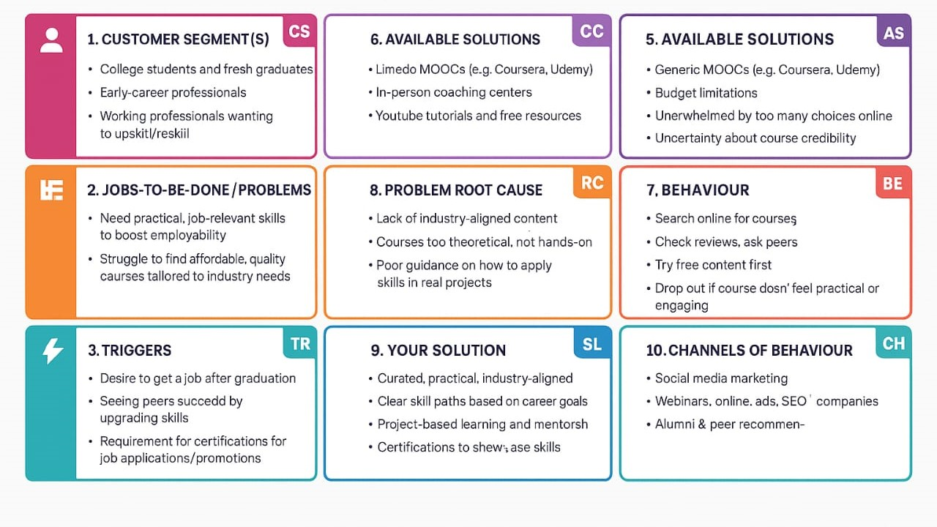**Template:**